Call Sheet – Monday 8th February 2016

Arctic Monkeys – Do I Wanna Know (Final Cut)
Unit Call Time: 15:00 | Weather: Cloudy with light rain  Sunrise: 07:28  Sunset: 17:02 |  | Cloud & Chance of rain  Highs of 7 Degrees
Director:  Producer:  Camera:  Client Contact:  Venue Contact: | Daisy White  Georgia Dye  Elle Carrington  Natasha Warr  Mrs. L. Jones | 07944682911  07766821621  07508138358  07455557957  01322 662320 | daisy.white14@hotmail.co.uk  georgiadye111@hotmail.co.uk  ellsbells1760@hotmail.co.uk  natashawarr@hotmail.co.uk  stpeters@globalnet.co.uk

Preliminary Schedule – Subject to Change
Time | Action
15:00  16:35  18:15  18:30  18:45 | Unit Call & Setup  Roll Cameras  Wrap  Pack Away  Leave | Unit Wrap Time 18:45

Location
St Peter’s Church  College Road  Hextable  Kent  BR8 7RH  Phone: 01322 662320 | 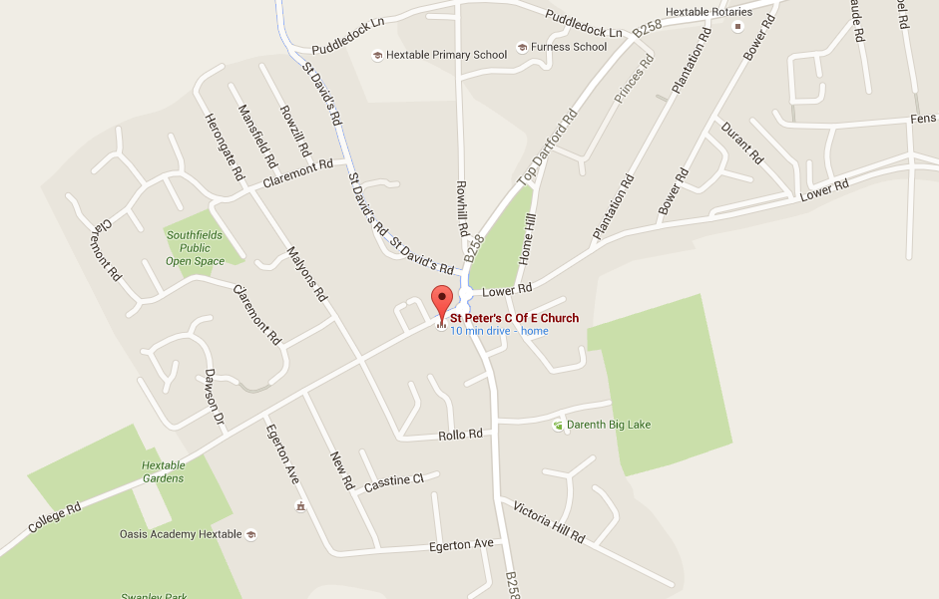

Health & Safety
- All crew must be weary of loose cables and the equipment that will be in the venue as it can obstruct the pathway.
- All crew must treat equipment with care when carrying and using it
- All crew must carry the heavy equipment safely and properly to decrease risk of damage to props or harm to the carrier
- All crew must wear sensible footwear (No sandals/Flip-Flops)

Full Risk Assessment on the blog.

Production
Audio: Speaker on set Parking: On Site Catering: N/A Toilets: On set Medical: On set

